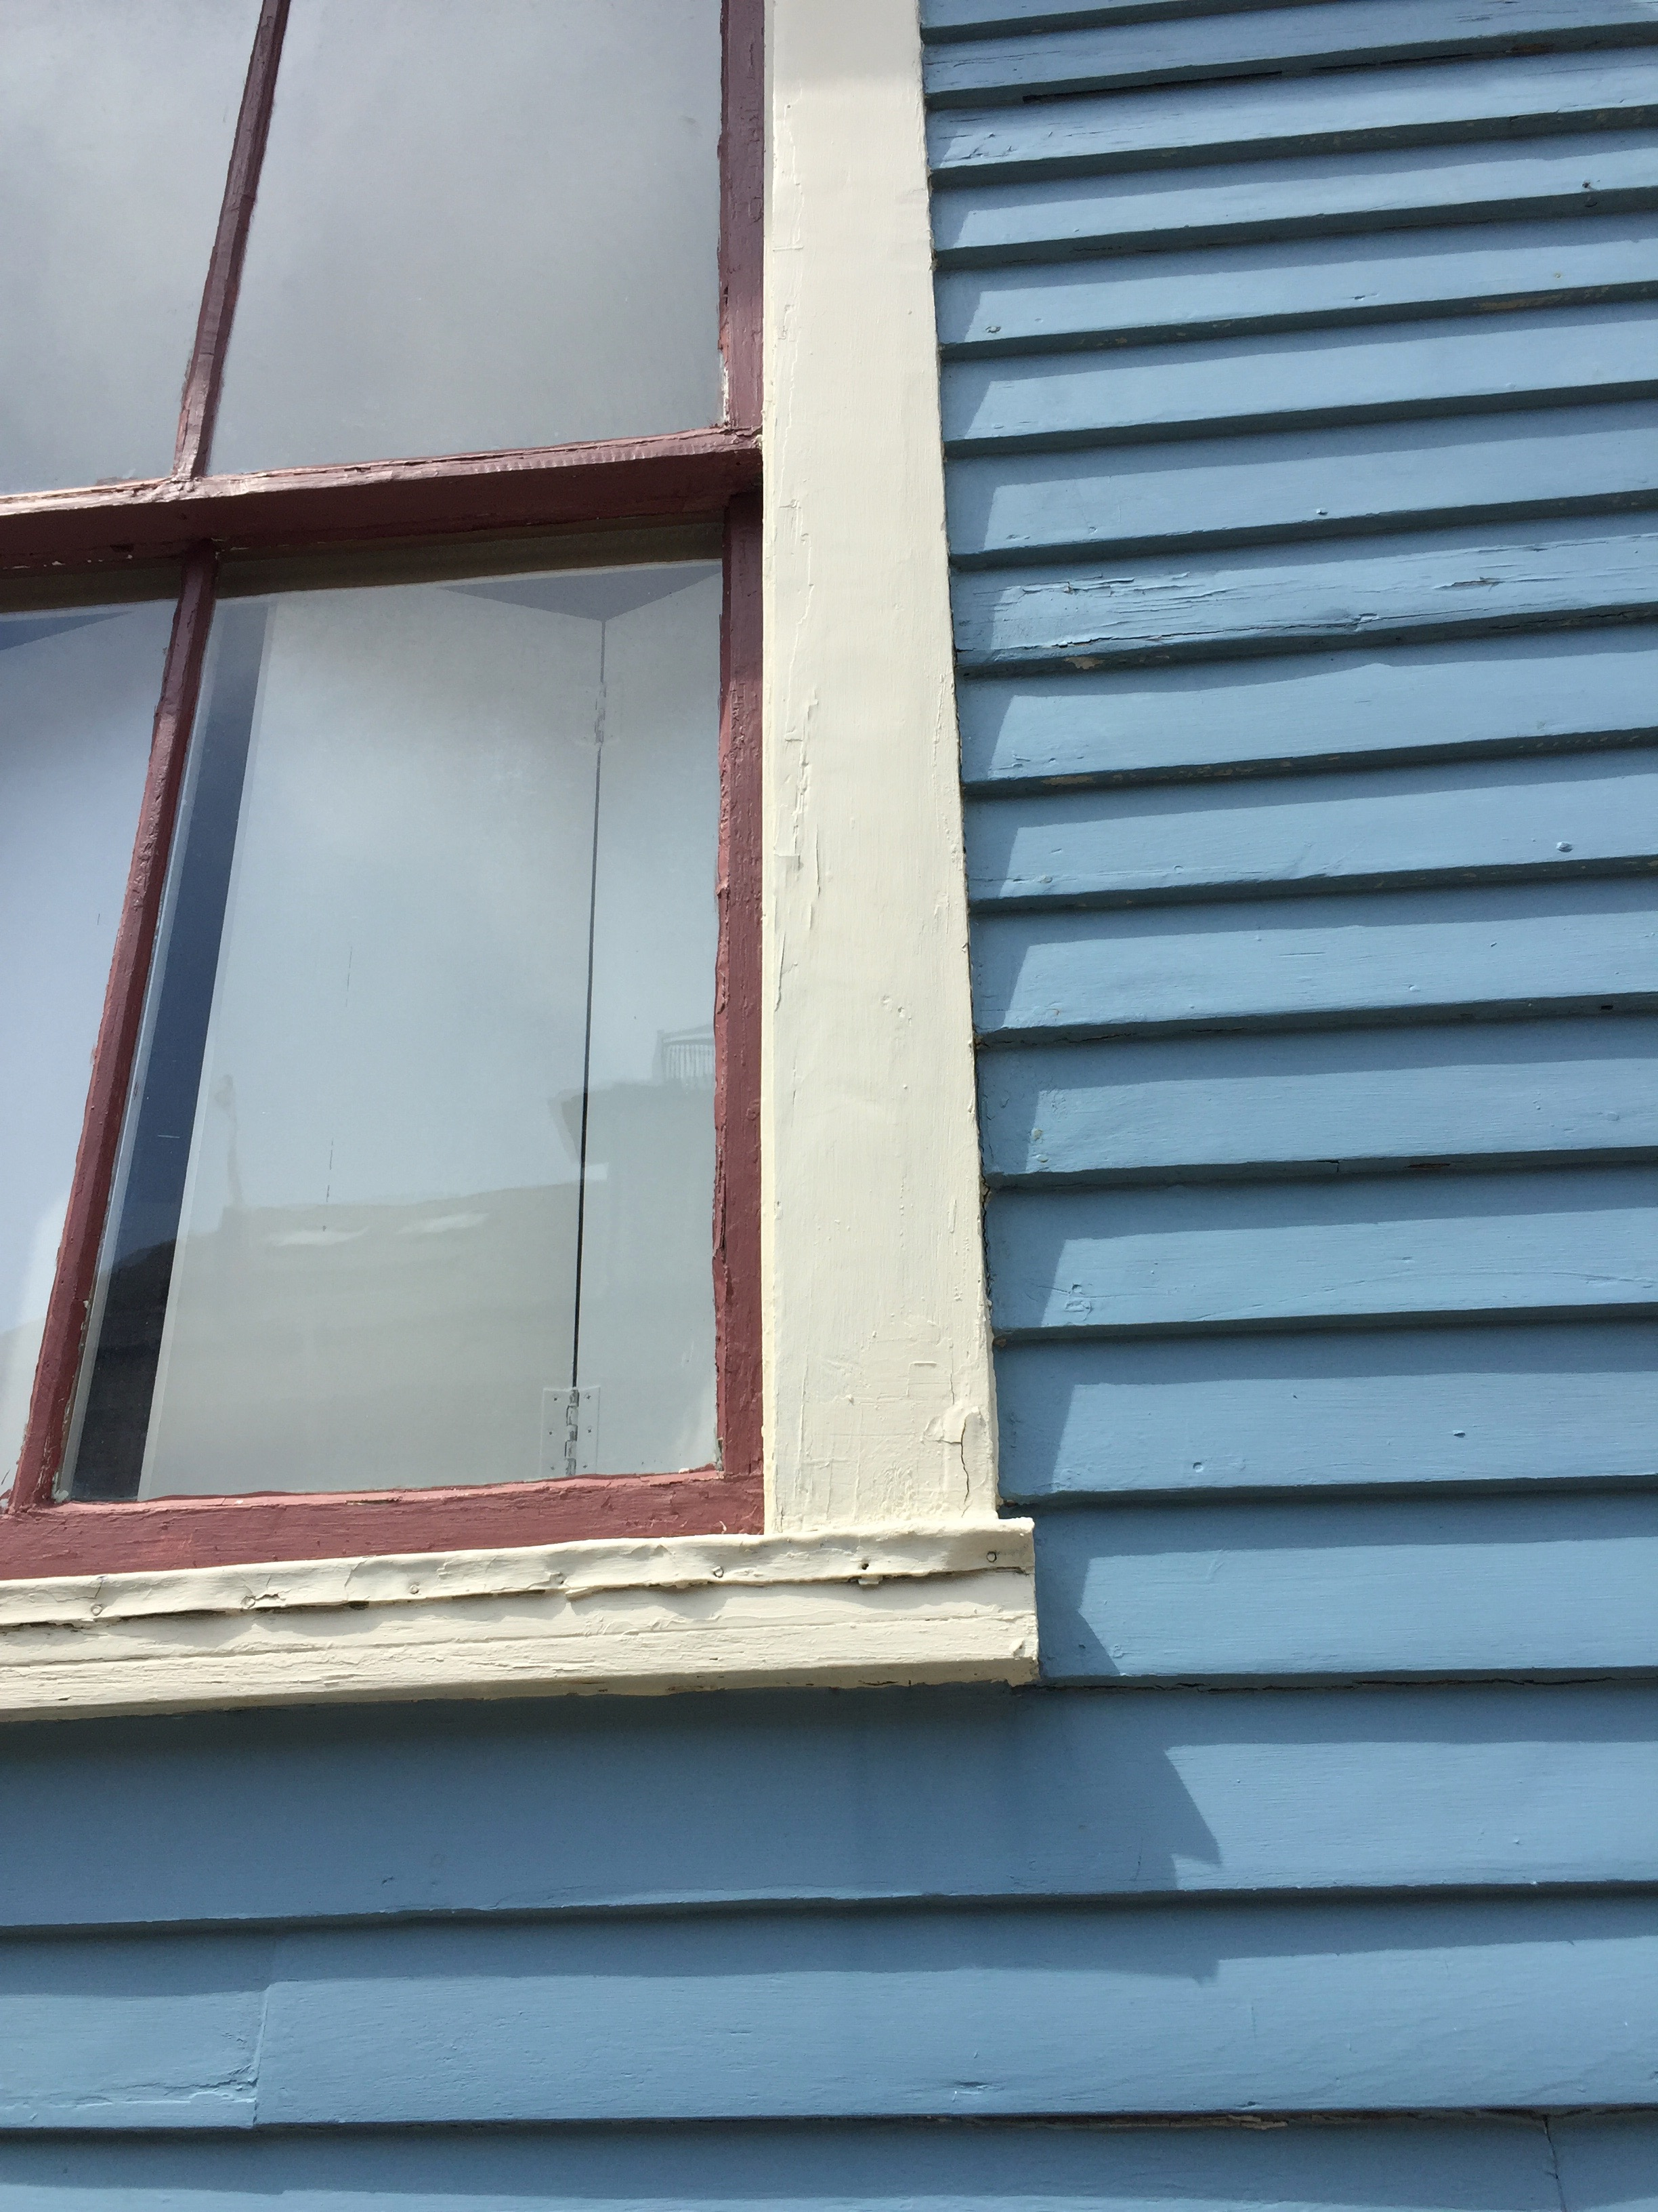  - May 22, 2018  Historic Windows: making the case  10:00 – 12:00 Worcester, MA  For everyone who wants to know more about historic windows, join us for a morning of presentations, discussion and networking. Visit our Eventbrite site for more details, information and to register. Organized and supported by the following organizations and local partners:  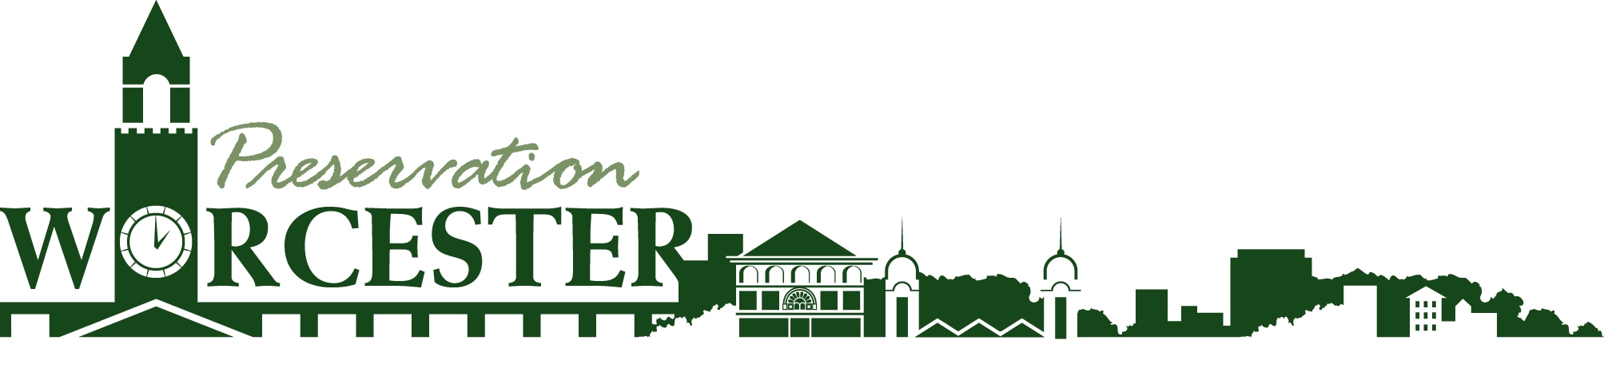  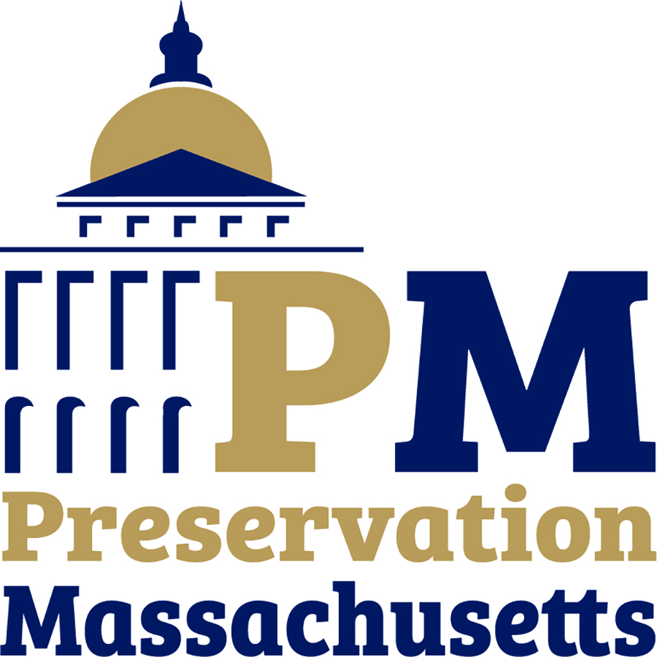  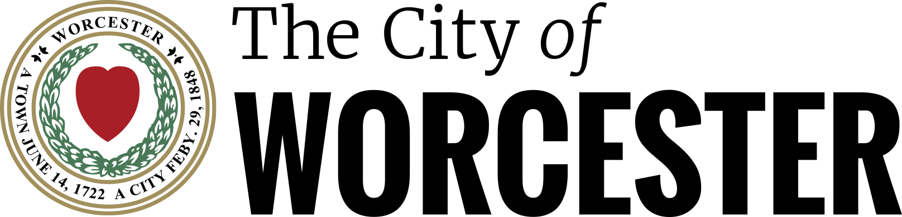 | Meet Window Repair Experts  ____  Learn how “Restore and Repair” is an option  ____  Hear about Real World Case Studies  ____  Get information & Resources  ____  Presentations by Heartwood Window Restoration, Old Window Workshop and others  Historic Windows: Making the Case  Levi Lincoln Chamber  Worcester City Hall  455 Main Street, Worcester  RSVP: https://windowtalkworcester.eventbrite.com  Or Call 617-999-3256

